Draft Order testing 22-02-2022

Draft order

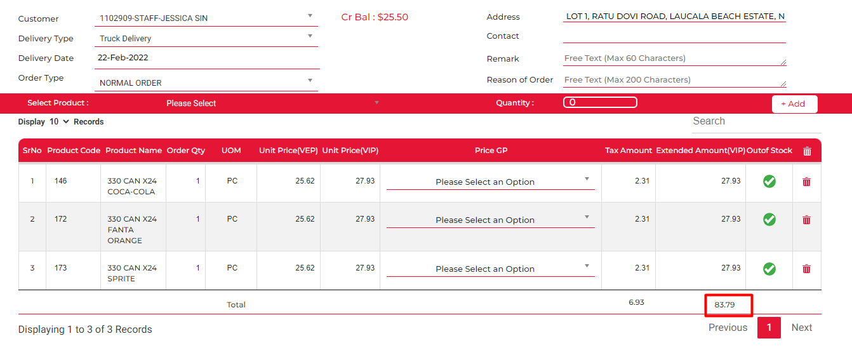

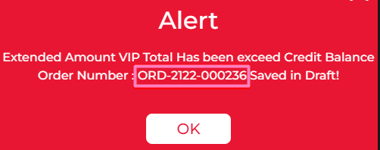



Order number: 236

Test #1 Add Product

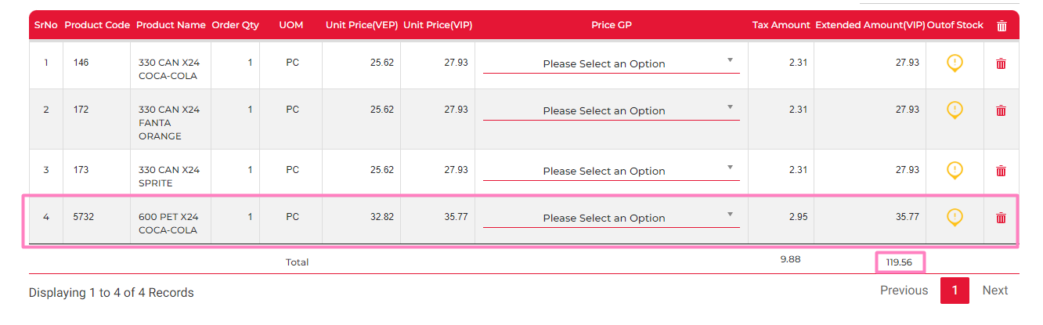



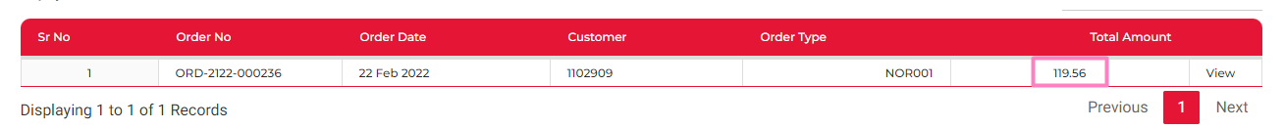

Result: WORKING

Test #2 Remove Product

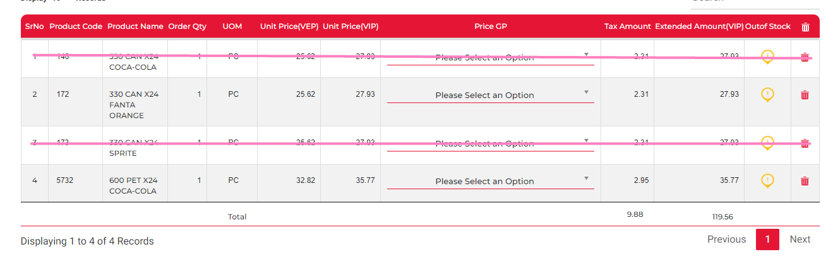

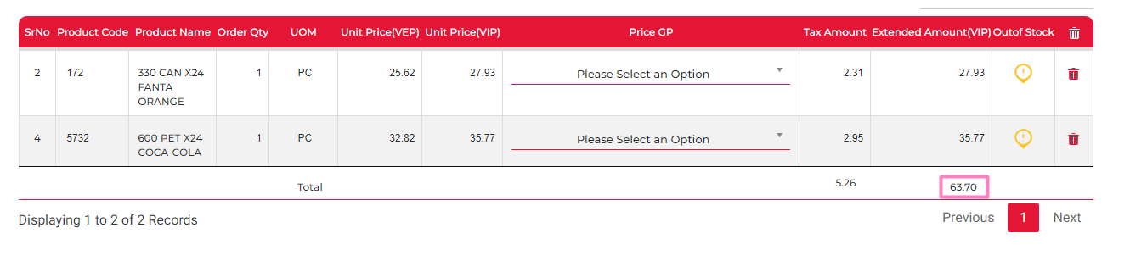





Result: WORKING

Test #3 Change Quantity

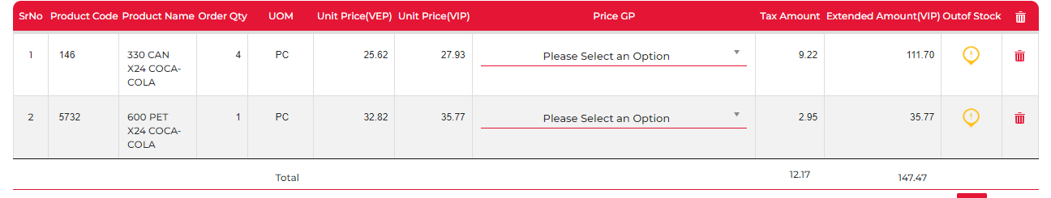

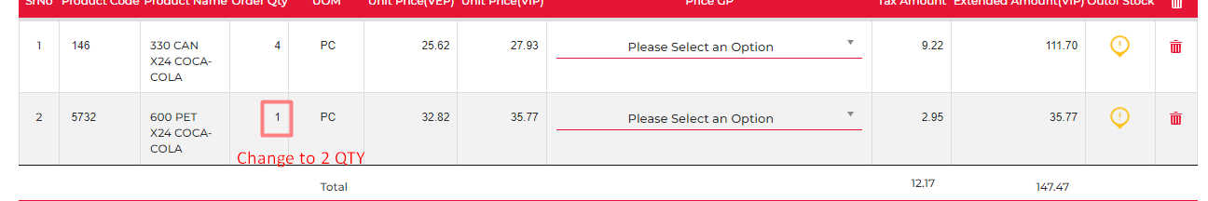

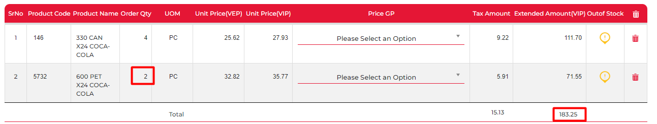





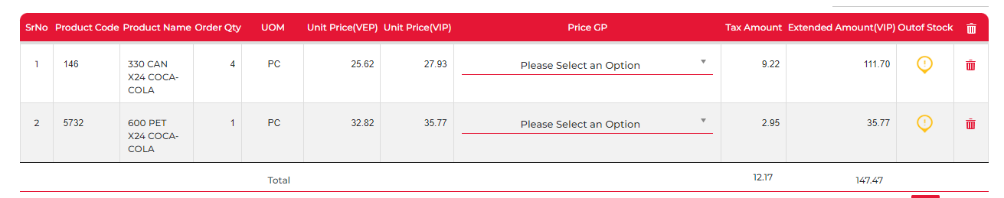

Order Details is not updated when opened in generate order

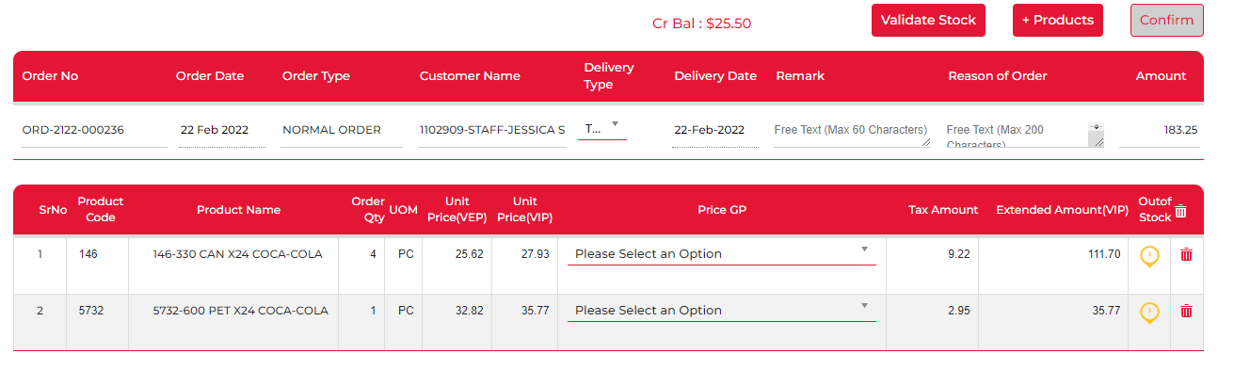

Also not updated in my cart screen

Results: NOT WORKING

Multiple draft order

Order Number: 236

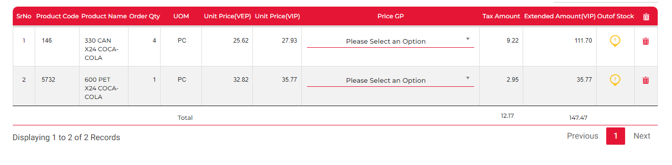

Order Number: 237

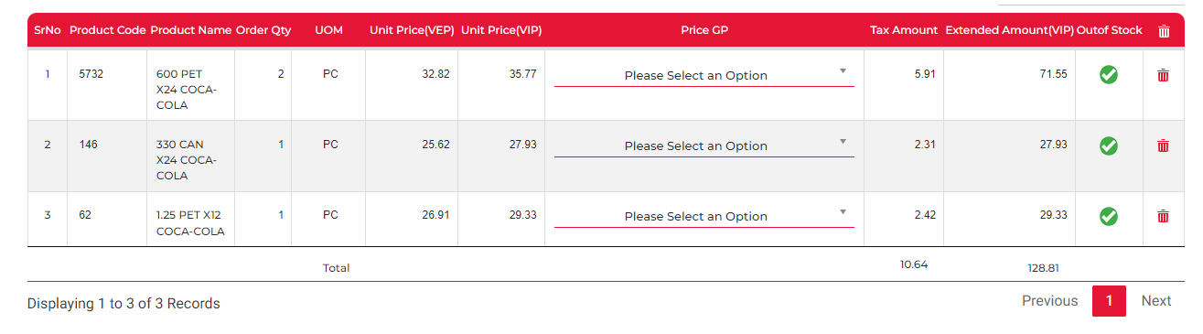





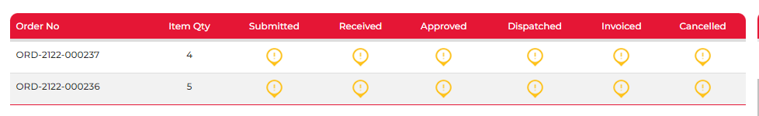

Test #4

Adding items & making sure that it doesn’t impact the other draft order

Order: 236

Adding item 214 qty 3

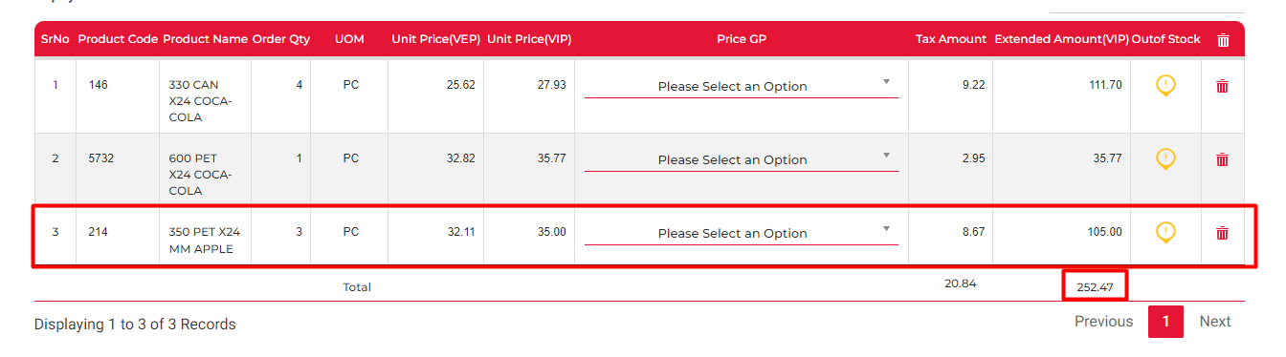





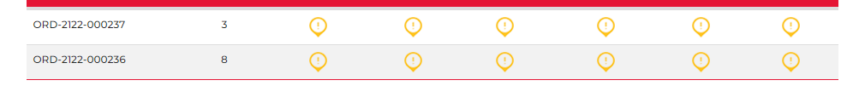

Order 237:

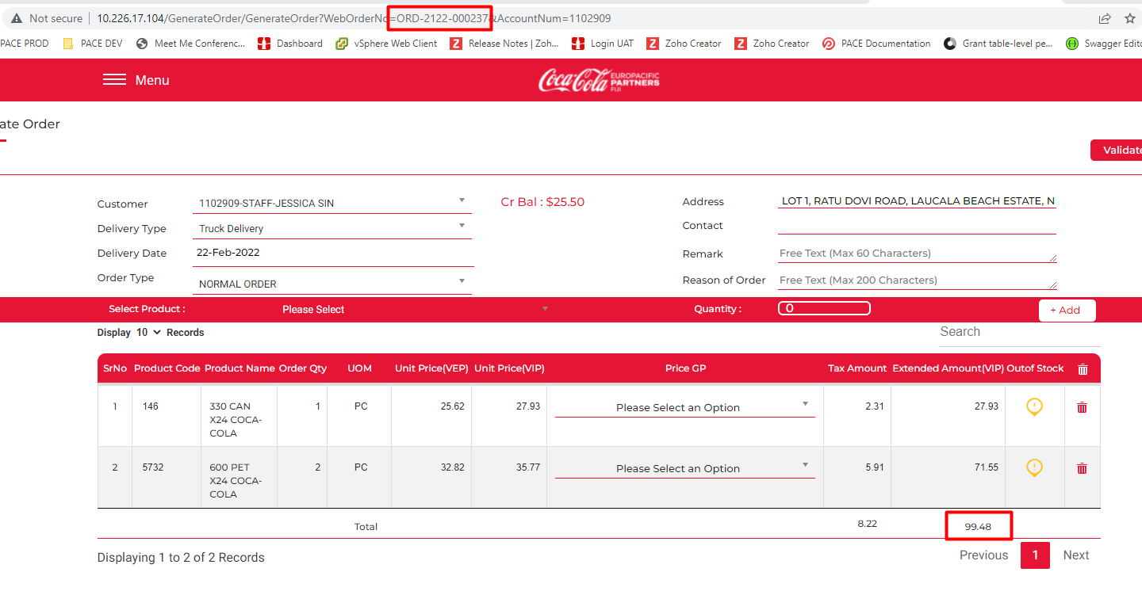

Changes were done to order 236, but order 237 was impacted (item #3 was removed from the order)

Results: NOT WORKING

Test #5 Removing items & making sure that it doesn’t impact the other draft order

Order 237

* Removing item 146

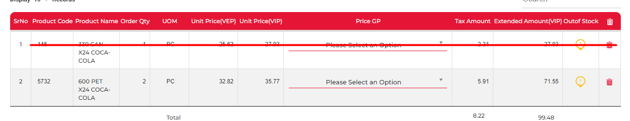

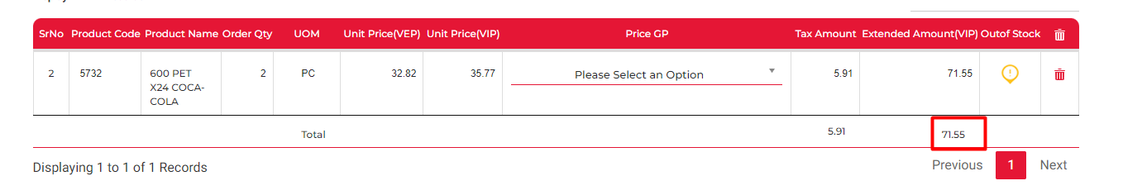



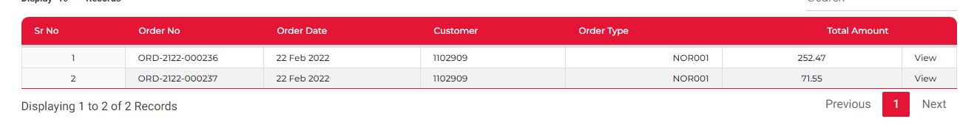

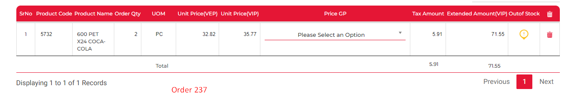

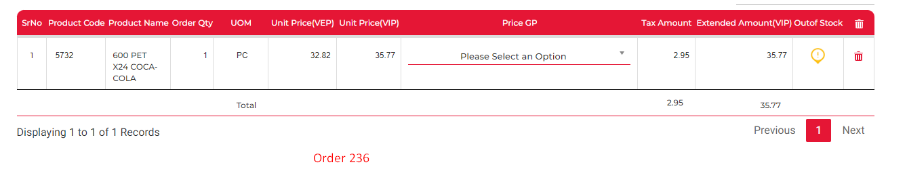

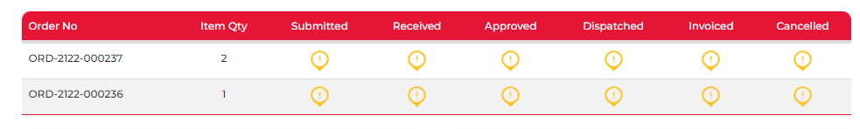

It removed item 146 (qty 4) from order 236 as well

Results: NOT WORKING

Test #6 Changing qty & making sure that it doesn’t impact the other draft order

Order 237

Changing qty from 2 to 5

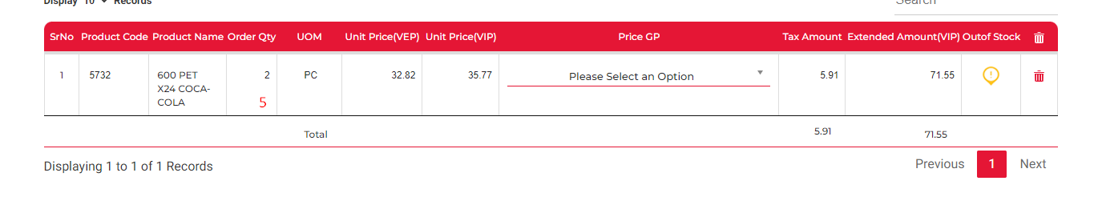

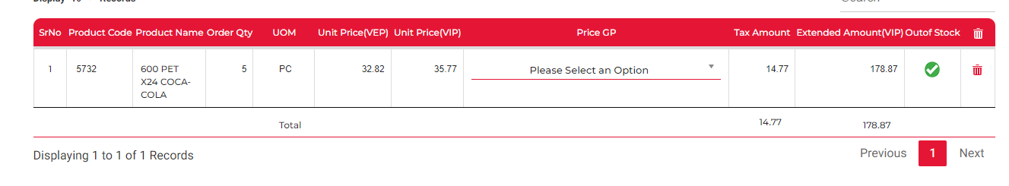



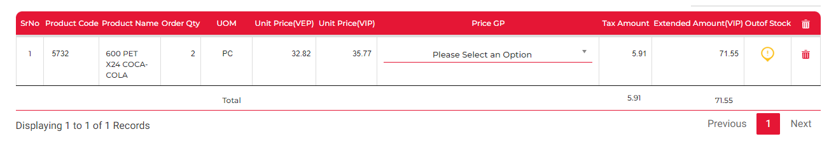

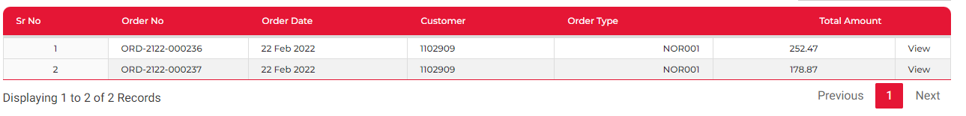

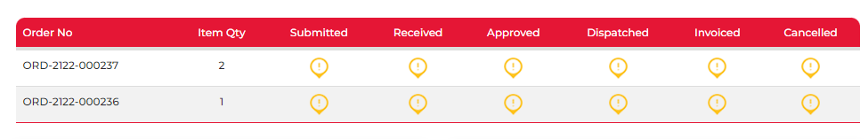

Quantity is not updating

Results: NOT WORKING

Draft Order and amending it to be less than staff balance to submit the order for approval

Test #7 New Draft Order

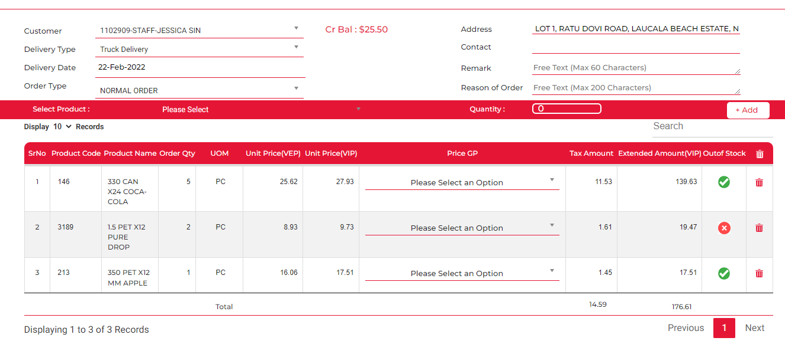



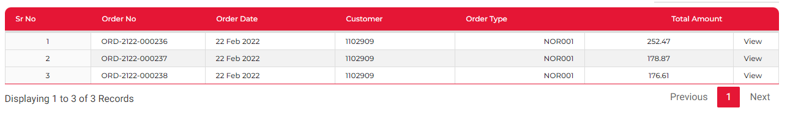

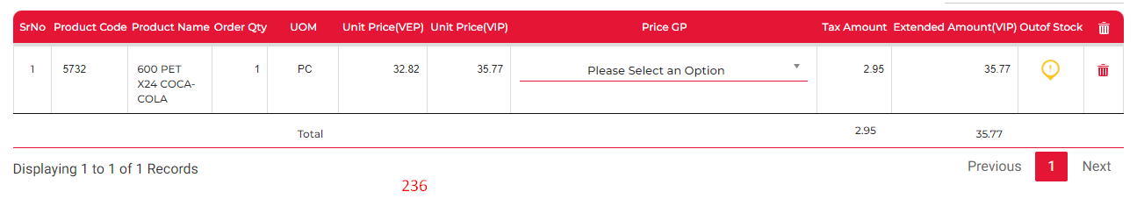

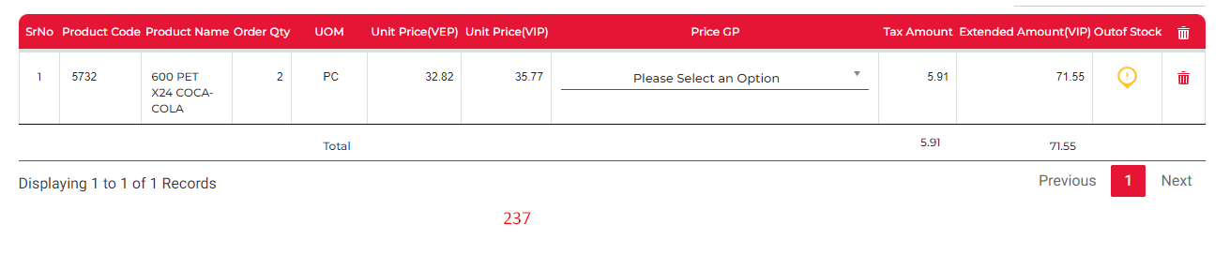

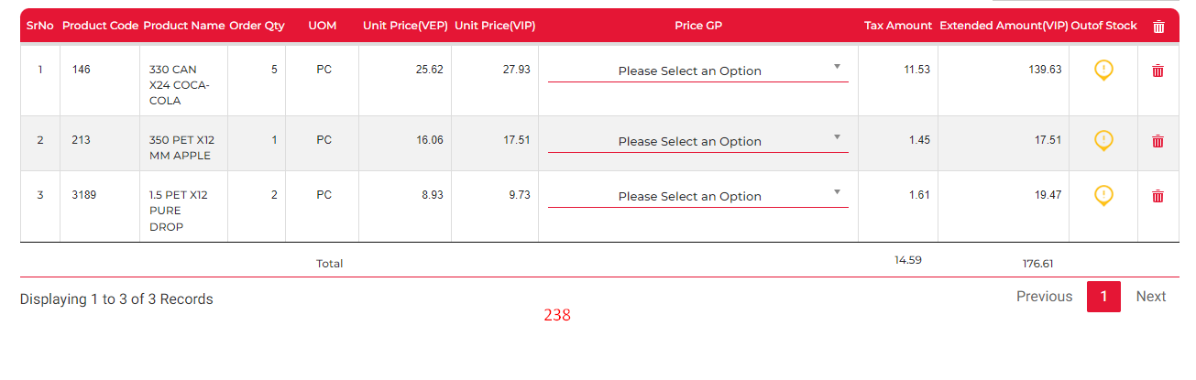

7.a Remove items 146 & 3189 and submit order.

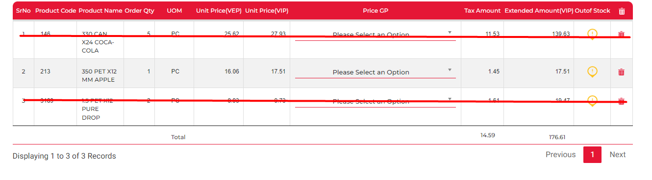

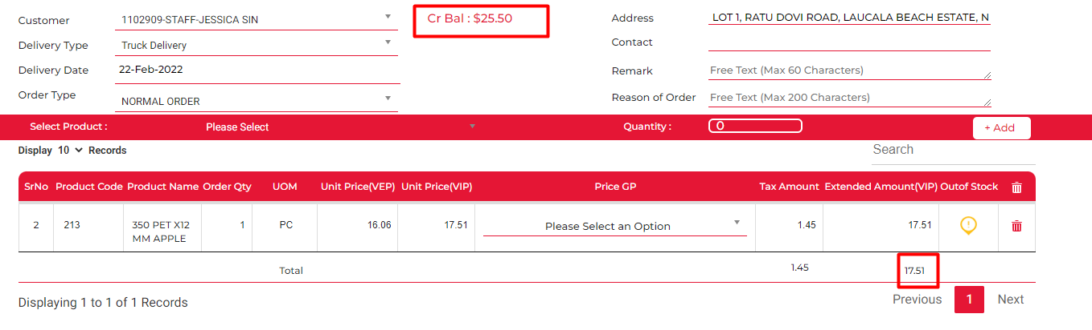



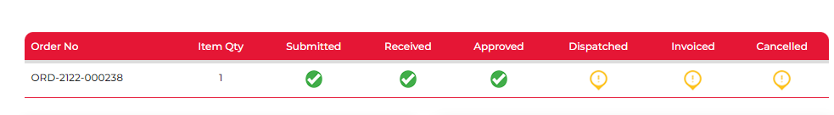

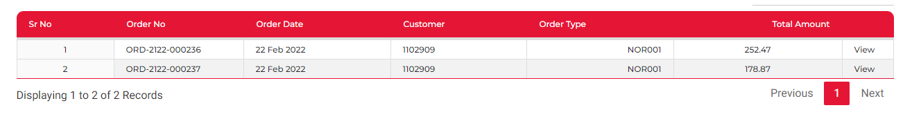

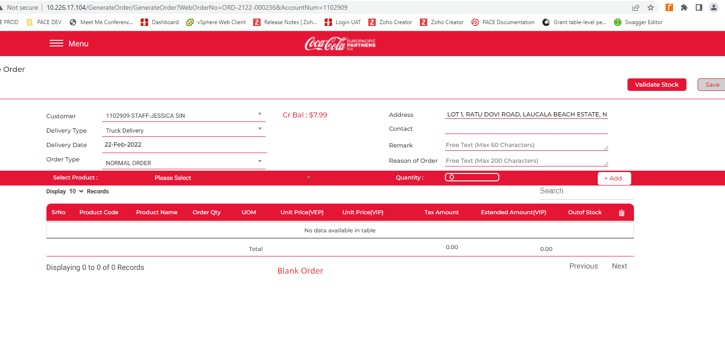 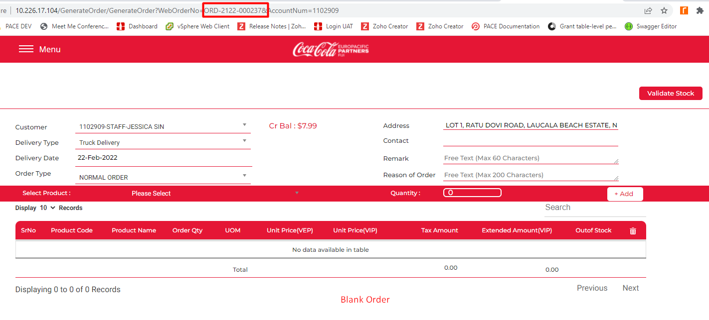

From the testing, it can be seen that the previous saved draft order becomes blank after an order has been successsfully submitted ( Balance > total amount) and the order history from the dashboard is cleared. This should always show the last 5 order

Results: PARTIALLY WORKING BUT IT AFFECTS THE OTHER DRAFT ORDER